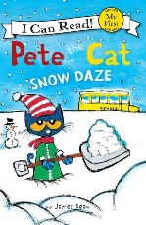
Pete the Cat
Name: ______________________________________
Nº _____ Class: _____ Date: _____/_____/ _____
Snow Daze
by James Dean

- What’s the weather like? Tick the right answer.
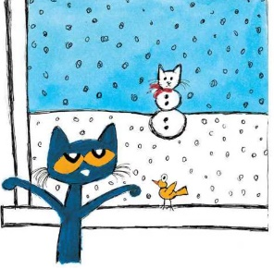
It’s sunny.
It’s snowy and freezing!
It’s cloudy.
It’s rainy.

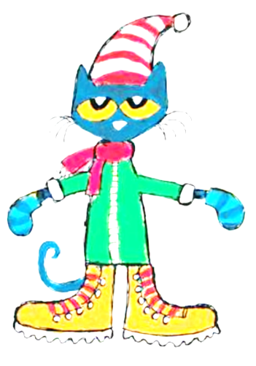
- What is Pete wearing? Read and link. Then colour Pete’s clothes.
Pete is wearing
a woolly hat,
blue mittens,
a red scarf,
a green coat
and yellow boots.

- It’s a snow day! What is Pete doing? Order the pictures according to the story.
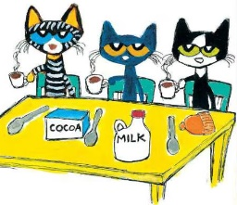 |  | 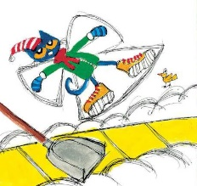 |  | 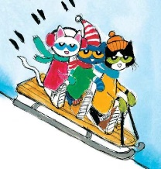
drinking hot chocolate |  | making snow angels |  | sledding
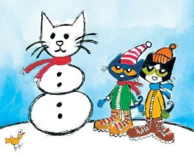 |  | 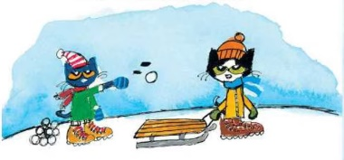 |  | 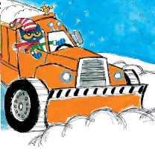
making a snow cat |  | throwing snowballs |  | plowing the streets

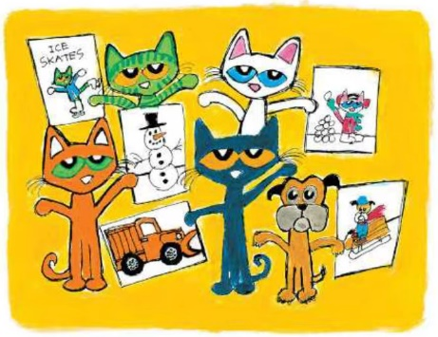
- What’s your favourite winter activity? Draw and write.
I like ____________________________________.

