I ____________ (have) a dream where I _____________ (wake up) in the middle of the night and then _____________ (walk) up to my attic. There _________ (be) a huge spider web and a giant spider. It then ___________ (chase) me into a corner. I ____________ (jump) out the nearest window onto the street but it _____________ (continue) to chase me through the streets of downtown Vancouver. I _________________ (wake up) before it _____________ (catch) me. | 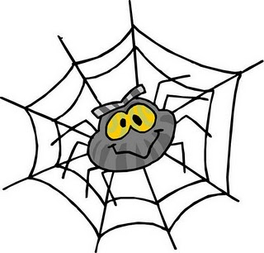
I _____________ (have) a dream that my family ___________ (be) replaced with a group of look-alike aliens. I ___________ (see) that they ___________ (be) aliens, and my family ___________ (try) to escape them, but I _____________ (realize) that my brother was left behind in the haste. I ____________ (go back) to get him, but we were found and kidnapped. In the dream, my family ___________ (be) in one car and they ___________ (chase) the car that the aliens _______ (have) us in. I ____________ (push) my brother out of the door so that he would be able to escape. Then he ____________ (turn) into a piece of paper floating down the highway. | 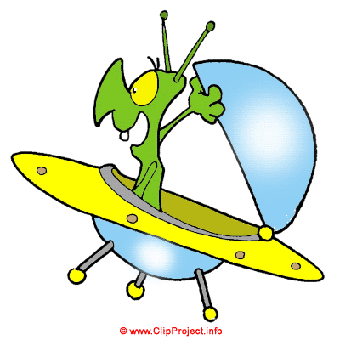
I _________ (have) a dream last night that I need help with. Well, I ___________ (smell) fire late at about 3 or 4 am. I ______________ (wake up) and ___________ (go) outside for a minute and all my neighbors were standing outside of their houses looking around, because they probably ___________ (smell) it too. I was tired and had school so I __________ (go back) inside and __________________ (fall asleep). About an hour or so later I __________ (wake up) again and ___________ (walk) into the kitchen. There ________ (be) something on the stove burning and there __________ (be) huge flames coming from it. Once I __________ (see) the flames I __________ (freeze). I ____________ (know) I was supposed to run and get out of the room, but my feet ___________ (seem) like they ______________ (weigh) a ton and I _________ (can) hardly move. I __________ (start) choking and then I ______________ (wake up). | 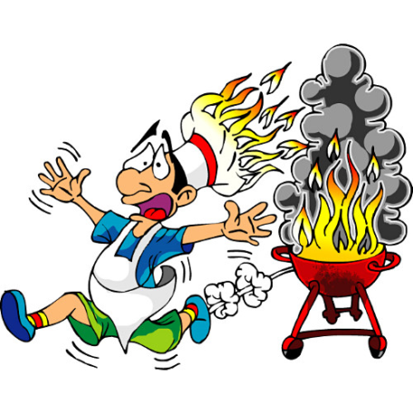
A while ago I ____________ (dream) that I was getting married. Everything ___________ (seem) to be normal at the wedding, until I ____________ (look) at a picture that someone ___________ (take). My gown ___________ (be) black, as ___________ (be) my bridesmaids. The whole male wedding party also _____________ (wear) nothing but black! I'm only 14 years old, don't have a boyfriend, and definitely DON'T want to be married. Can you tell me what this means? | 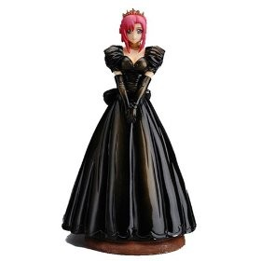
I _____________ (dream) that for some reason I ____________ (paint) my teeth all different bright colours: red, green, blue and yellow. Even my tongue and my gums ____________ (be) brightly coloured. I then remember that there ________ (be) also a hole in one side of my cheek, and everyone at work _____________ (can/see) through this hole. I __________ (be) at work, but I don't think I __________ (be) too embarrassed. I just ____________ (think) that it ________ (be) really strange, and quite nerve-wracking that I suddenly __________ (get) this huge hole in the side of my face. | 